1.udate your github

2.add scrpits folder and add start ..stop file .

*** in start_server.sh***

#!/bin/bash

sudo systemctl daemon-reload

sudo systemctl start gunicorn.service

*** in Stop_server.sh***

sudo systemctl stop gunicorn.service

sudo rm -rf /home/ubuntu/new_chatapp/fundoo

3. add appspec.yml file

version: 0.0

os: linux

files:

- source: /

destination: /home/ubuntu/new_chatapp

hooks:

BeforeInstall:

- location: scripts/Stop_Server.sh

timeout: 300

runas: root

AfterInstall:

- location: scripts/Start_Server.sh

timeout: 300

runas: root

5.create role:-

Create 2 roles

1)create Ec2codedeploy role:-

-Select AWS service

-Select EC2 Use Case

-Select "AmazonEC2RoleforAWSCodeDeploy" Policy

-give the role name and tag and create policy

2)create Codedeploy role:-

-Select AWS service

-Select Codedeploy Use Case

-keep default Policy

-give the role name and tag and create policy

6.go to instances

-select backend instance

-go to action

-select security

-select modify IAM role

-add your created EC2 IAM Role

7.login to putty using frontendserver

then login to backend

and install codedeploy agent

command:-

- sudo apt-get update

- sudo apt-get install ruby-full

- sudo apt-get install wget

- cd /home/ubuntu

- wget https://aws-codedeploy-ca-central-1.s3.ca-central- 1.amazonaws.com/latest/install

- chmod +x ./install

- sudo ./install auto

- sudo ./install auto > /tmp/logfile

- sudo ./install auto -v releases/codedeploy-agent-###.deb > /tmp/logfile

- sudo service codedeploy-agent start

- sudo service codedeploy-agent status

8.go to codedeploy service

i) Create application

ii)select deployment group

-give deployment group name

-select codedeploy role

-deployment type in-place

-Environment configuration =>Amazon EC2 instaces

=>Select key Name and value your backend intance(the instance on which you want to deploy apllication)

-Disable Load Balancer

-create Depoyment group

9. Create Deployment

-Select your deployment group

-revision type =>My Application stored in Github

-paste github token =>How to generate token

=>go to github settings

=>Select Developer Settings

=>Personal access token

=>generate token

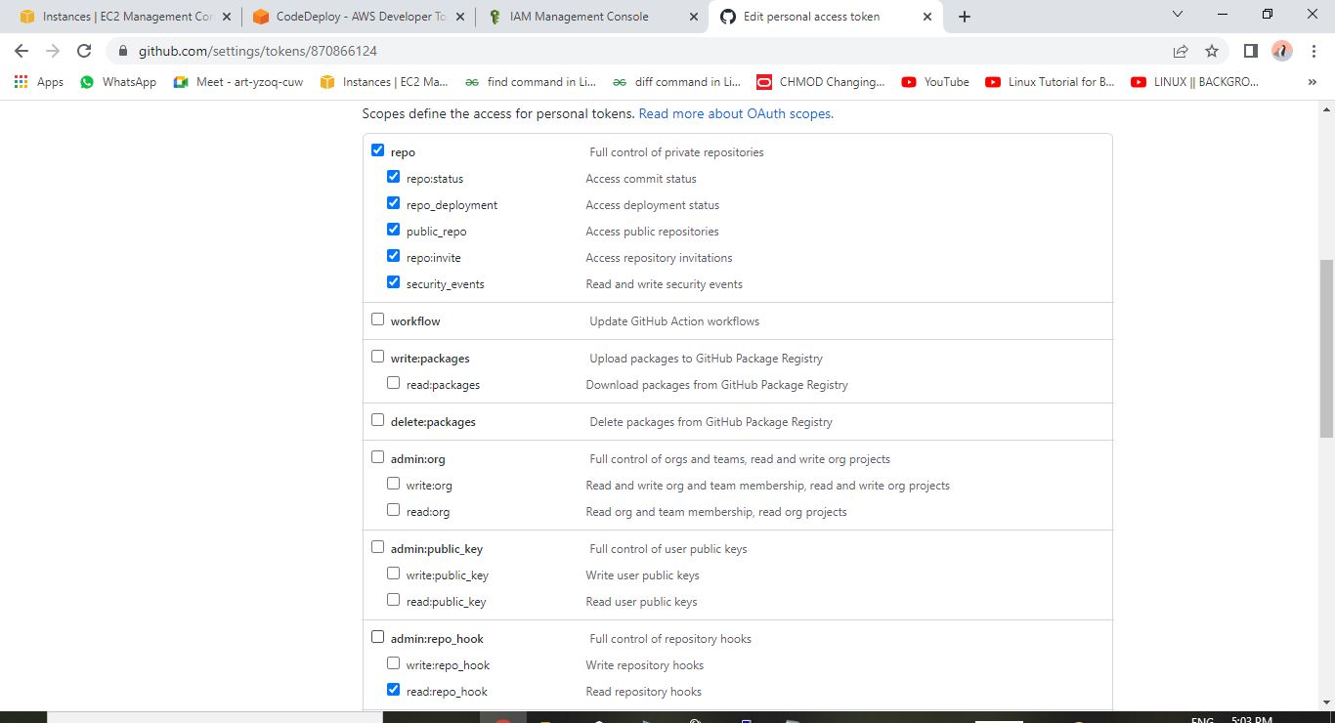

-copy token and paste in deployment token(save the token in notepad)

-connect to github

-paste repositiory name(note:no spaces between and before repository name)

-paste latest commit id

-click overwrite the contetent

10. Create pipeline

-give name to pipeline

-new service role

- source provider => github version 1

=>connect to github

=>select repositiory and branch

-skip Build stage

-Deploy

=>select Aws CodeDeploy

=>select Application Name and Deployment group

-create pipeline

Now check source and deploy is succeeded

In web tab paste frontend ip

Now go to index.html file in gitub make changes

Go to deployment add edited commit and again check the web tab with frontend ip if changes are reflecting or not

To check a codedeploy agent log

less /var/log/aws/codedeploy-agent/codedeploy-agent.log